**Health Insurance in the Digital Age: How AI and Telemedicine are Reshaping Coverage**

Every industry is changing due to technological improvements, and the insurance sector is no exception. Digital integration has simplified procedures and guaranteed a flawless client experience in conventional and essential Health Insurance activities like policy issuance, claim administration, and renewal process. Technologies such as Artificial Intelligence (AI) and telemedicine are changing the insurance sector in a positive way by acting as strong tools.

**The Role of AI in Health Insurance**

**Customized Risk Evaluation**

These days, technology is a tool that allows insurers to capture the subtleties of individual health and rely on vast volumes of previous data. In the West, health bands are already integrated into the cost of your [Health Insurance](https://www.acko.com/health-insurance/) coverage. A location with extremely individualized insurance policies is not far away. As a result, insurers will be able to provide more focused and reasonably priced plans, increasing accessibility and affordability.

**Prevention and Early Disease Detection**

Better results and efficient treatment depend on early detection. AI-powered technologies assist in the analysis of clinical data and medical imaging to accurately detect early warning signals of diseases including cancer and heart problems. This ultimately lowers healthcare costs by enabling insurers to provide preventative care programs and encourage healthy behaviours.

**Virtual Assistants and Chatbots**

Today, the majority of insurers provide customer service through chatbots and virtual assistants. Rather than using these tools to serve customers, astute insurers employ them for screening purposes. However, the availability of these technologies around the clock guarantees that human agents have less work to perform, which ought to result in higher-quality service provision.

**AI-Powered Claim Settlements in the Health Insurance Sector:**

Fraud detection is one of the most notable applications of artificial intelligence. In India, claims are vulnerable to fraud since documents might be falsified or contain inaccurate information. Artificial Intelligence (AI) is being used to examine vast volumes of data and spot patterns that point to fraudulent events or actions.

Artificial intelligence is replacing fraud detectives since it's more efficient and takes less time to identify and unlock fraud patterns. The amount of data determines how long it takes a typical human to analyze; the more data, the longer it would take. However, data analysis using artificial intelligence is faster and more effective.

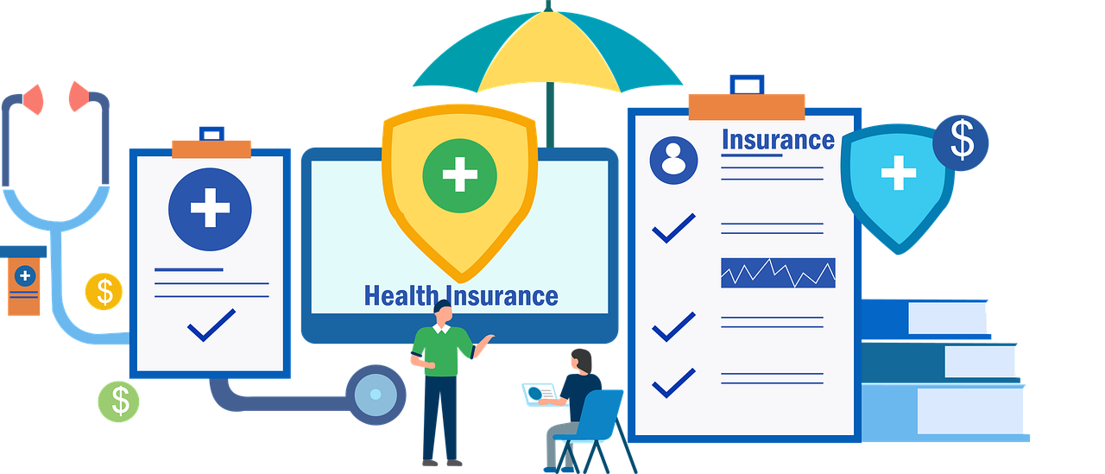

**Comprehending Telemedicine: A Revolution in the Provision of Healthcare**

Telemedicine, often known as telehealth, is the umbrella term for a variety of services that make it possible for people to get medical care from a distance. Digital prescriptions, remote vital sign monitoring, electronic health data sharing, and virtual doctor consultations are a few examples of this. The fundamental idea of telemedicine is to reduce the distance between patients and medical professionals, thereby increasing access to high-quality care, especially in situations when physical presence may be difficult.

**Advantages of Including Telemedicine in Health Insurance Programs**Modern Health Insurance policies that incorporate telemedicine offer numerous advantages to patients and healthcare organizations:

* **Improved Availability:** Geographical restrictions are removed with telemedicine, making it possible for everyone to receive medical expertise wherever they are. For patients who might otherwise find it difficult to get specialized care, this is especially important if they live in rural or neglected locations. Senior citizens also benefit from it the most.
* **Time Savings:** With virtual consultations, there's no need to drive to a hospital, stand in busy waiting areas, and take a long time to get an appointment. This is particularly helpful for routine check-ups, follow-up appointments, and mild illnesses.
* **Cost Effective:** Through the elimination of travel expenses, remote monitoring that lowers hospital readmissions, and the avoidance of needless ER visits for non-urgent diseases, telemedicine can lower healthcare costs.
* **Prompt Intervention:** By enabling early intervention and prompt management of health issues, remote monitoring and virtual consultations may be able to stop the advancement of certain disorders and improve overall health outcomes.
* **Continual Care:** By allowing people to consult with their usual healthcare practitioners even when they are not physically present, telemedicine promotes continuity of care. This promotes a steady patient-provider rapport.



**The Role of the Government in Encouraging the Use of Digital Health**

* The development of digital health and its incorporation into the Health Insurance sector is greatly aided by the Indian government.
* The goal of programs like the National Digital Health Mission (NDHM) is to link patients, insurance companies, and healthcare providers in a digital health ecosystem.
* The efficient provision of healthcare services would be enhanced by this unified digital platform, which will also permit the safe interchange of medical records and telemedicine.
* The government may promote the uptake of digital health technology and foster innovation in the Health Insurance industry by establishing a favourable regulatory environment and making investments in digital health infrastructure.
* Public-private partnerships can also aid in the creation of digital health solutions customized to the particular requirements of the Indian population.

**New Technologies and Health Insurance: Encouraging Better Living in India**

* New technologies give Health Insurance companies in India new ways to encourage better living, including wearables, smartphone apps, and data analytics.
* Insurance companies can develop tailored, data-driven wellness programs that motivate people to take up healthier habits by utilizing these tools.
* For example, insurance companies may provide discounts to clients who track their sleep habits, physical activity levels, and other health-related data using wearable technology.
* These devices' data can be used to generate personalized wellness programs and provide incentives, including premium discounts or coverage advantages, to people who reach predetermined health targets.
* Furthermore, by using AI and telemedicine to spot trends and patterns in consumer behaviour, Health Insurance companies in India would be able to anticipate possible health problems and take action before they get worse.
* Insurers can contribute to reducing healthcare costs and raising customer satisfaction by providing preventative care options and encouraging early detection.

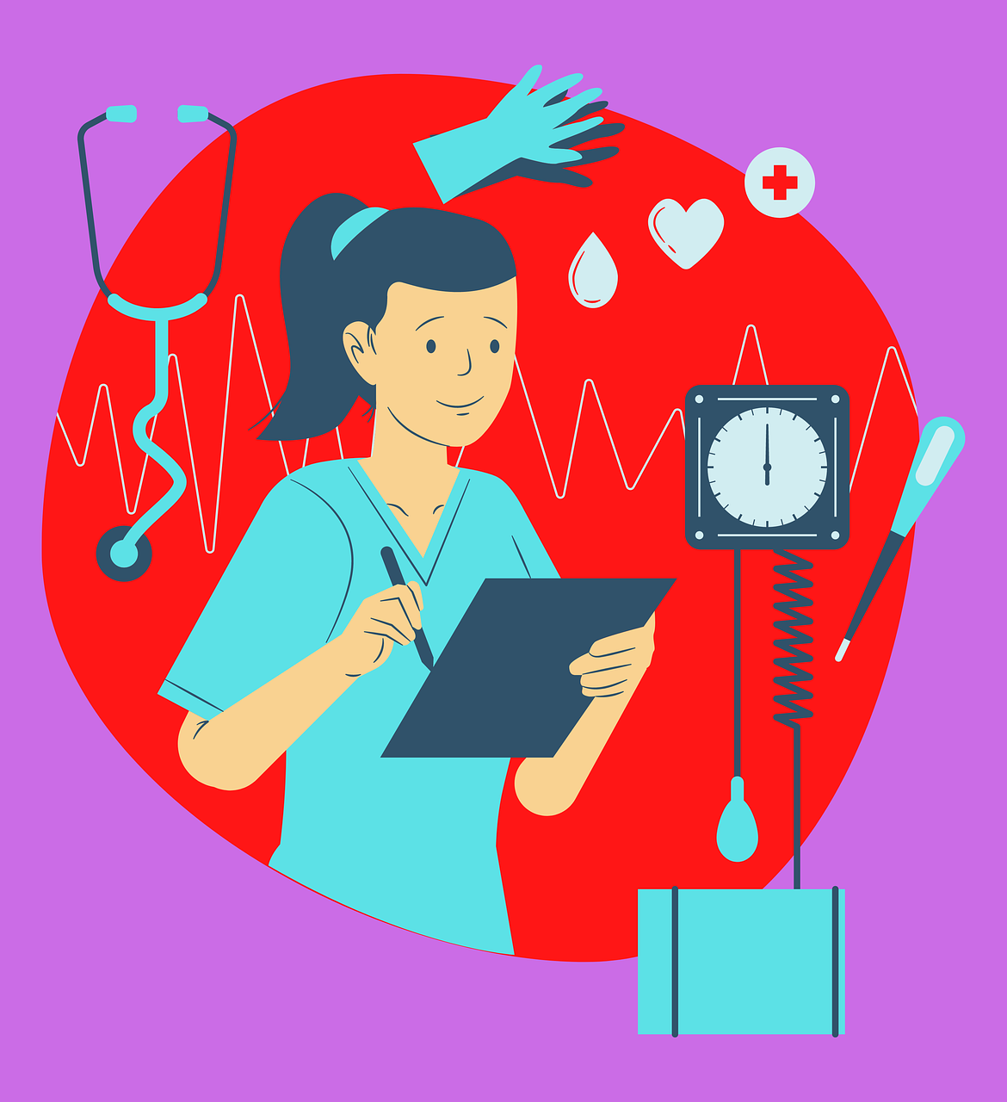

**Conclusion**

In India, the use of automation, AI, telemedicine, and other digital technologies has completely changed the way health insurers do business. Tech enablement in Health Insurance has produced a favourable environment for insurers as well as policyholders, from democratizing Health Insurance and providing better services to beneficiaries to cutting costs and enhancing overall health outcomes. Get in touch with ACKO, a digital-first insurer, if you intend to get Health Insurance.